Monitoring - Lab

Contents
Monitoring 3
1.1 Enable Monitoring 5
1.2 Monitoring using JConsole 5
1.3 IBM Monitoring and Diagnostics Tools for Java Health Center 10
1.4 Using IBM Monitoring and Diagnostics Tools for Java Health Center to Debug a Response Time Issue 25
1.5 Summary 31
Appendix A. Notices 32
Appendix B. Trademarks and copyrights 34

Monitoring
The monitor-1.0 feature provides monitoring support for user runtime components like:

- JVM
- Web applications
- Thread pool
- Session management
- Connection Pool

This monitoring feature is different from the Performance Monitoring Infrastructure (PMI) available in WebSphere Application Server. The monitoring feature collects performance data at runtime and the data is available as attributes on JMXBeans java objects. You can visualize the same data using Standard Java Development Kit tools such as jConsole. Also you can run a standard java client to fetch the performance values.
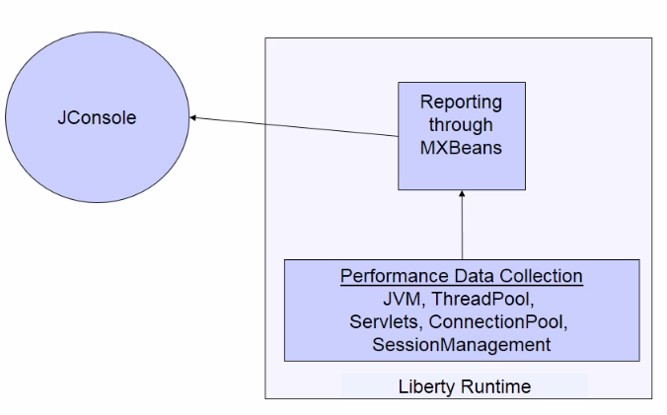
In this lab exercise, you will learn:
      - Enabling monitoring feature.
      - Use JConsole to monitor the Liberty Server
      - Use IBM Monitoring and Diagnostics Tools for Java Health Center to monitor the Liberty Server
      - Introduce load to the server and debug a response time issue.

As prerequisites, you should:
- Complete the Setup lab to set up the Liberty runtime environment.
 | Note :  If you were running the other administration labs, stop the adminCenterController to avoid port conflict.

To run this lab, your workstation must meet the following requirements:
- Approximately 8GB of storage available for the Windows 7 virtual image
- Approximately 3 GB of memory free to run the developer workbench and the server
- Connectivity to the internet is NOT required
- Please refer to the following table for file and resource location references on different operating systems.
Location Ref. | OS | Absolute Path
{LAB_HOME} | Windows | C:\WLP_<version>
{LAB_HOME} | Linux | ~/WLP_<version>
{LAB_HOME} | Mac OSX

Enable Monitoring
In this section we will create a new server with monitoring feature, and install the MoneyBank application.
- Change directory to {LAB_HOME}\wlp\bin
- Run the following command to create a new server
server create monitorServer
- Copy {LAB_HOME}\labs\management\5_Monitoring<timestamp>\server.xml to {LAB_HOME}\wlp\usr\servers\monitorServer directory.
- Review server.xml.
  - monitor-1.0 feature enables monitoring
  - localConnector-1.0 feature enables local connector.
  - restConnector-1.0 and ssl-1.0 features are required for remote monitoring.
- Copy {LAB_HOME}\labs\management\5_Monitoring\MoneyBank.war to {LAB_HOME}\wlp\usr\servers\monitorServer\dropins directory
- Start the server running the following command
server start monitorServer
- Point your browser to http://localhost:9080/MoneyBank
- Try some of the links on the web page to make sure they work. If the links do not work, make sure you are using the proper SDK as highlighted in the “Getting Started” lab.

Monitoring using JConsole
In this section we will start JConsole both locally and remotely for monitoring the application server.

Local monitoring
With the localConnector-1.0 feature enabled, you may start JConsole in local mode. This allows you to use JConsole to manage the server without having to provide a user ID and password, as long as the user running JConsole is the same as the user who started the monitorServer process.
- Start JConsole executing the following command
Windows: {LAB_HOME}\wlp\java\bin\jconsole.exe
Linux: {LAB_HOME}/wlp/java/bin/jconsole
Mac: jconsole should be on the path.
- Select monitorServer as the server to connect, then click Connect:
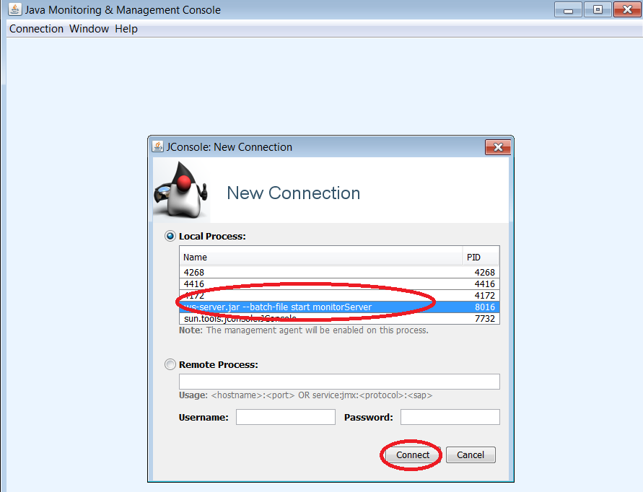
- A dialog box may appear after trying to connect securely. Click Insecure connection.
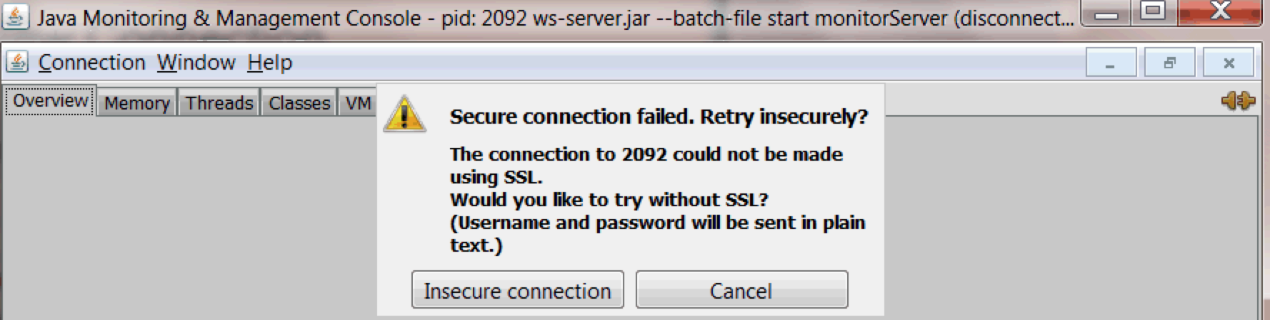

- After connecting you should see a graph of different JVM statistics as shown below :

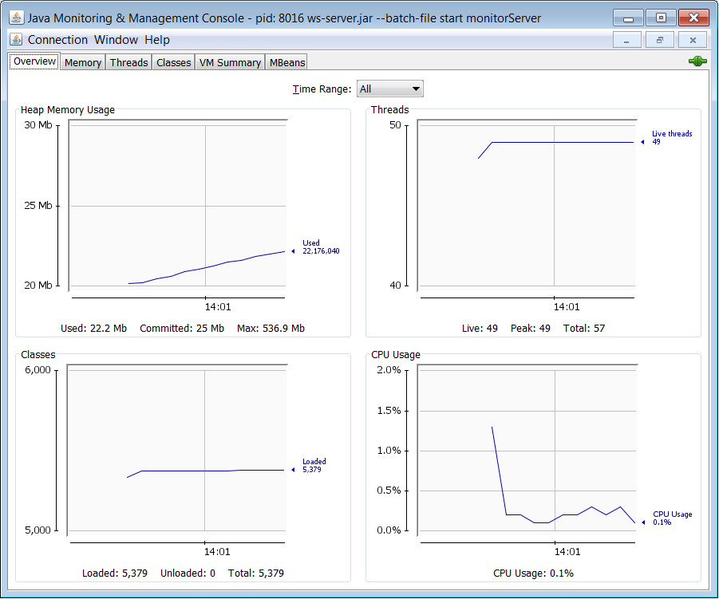

Remote monitoring
- To set up remote monitoring using the REST connector restart JConsole with the following options:
jconsole -J-Djava.class.path={LAB_HOME}\wlp\java\lib\jconsole.jar;{LAB_HOME}\wlp\java \lib\tools.jar;{LAB_HOME}\wlp\clients\restConnector.jar -J- Djavax.net.ssl.trustStore={LAB_HOME}\wlp\usr\servers\monitorServer\resources\security\key.jks -J-Djavax.net.ssl.trustStorePassword=mysecret -J-Djavax.net.ssl.trustStoreType=jks

Note: copying & pasting from this document may not work. Make sure there are dashes ‘-‘ before and after the four ‘J’ letters and spaces are correct. For Linux and Mac the jar separators on the classpath should be “:” colons not semicolons. Windows are semicolons. Mac users: wlp\java jars on classpath already.

- When prompted for New connection, enter the following:
  - URL: service:jmx:rest://localhost:9443/IBMJMXConnectorREST
  - User: userX
  - Password: passwordX

Navigation within JConsole
- Click on the MBeans tab then expand Websphere JVMStat Attributes to look at the JVM attributes:
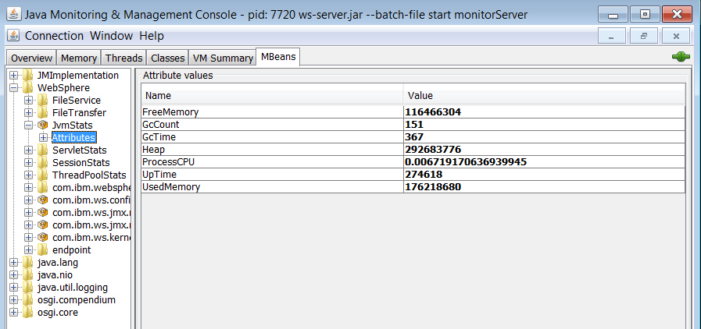
- Expand WebSphere ServletStats MoneyBank.InterestRate.

Note :
If you don’t see MoneyBank.InterestRate under ServletStats, first point your browser to:
http://localhost:9080/MoneyBank/InterestRate

- Note the response time of 5.07 seconds. (This may vary for your machine) This is a problem that we’ll be using the Health Center later to identify the root cause.
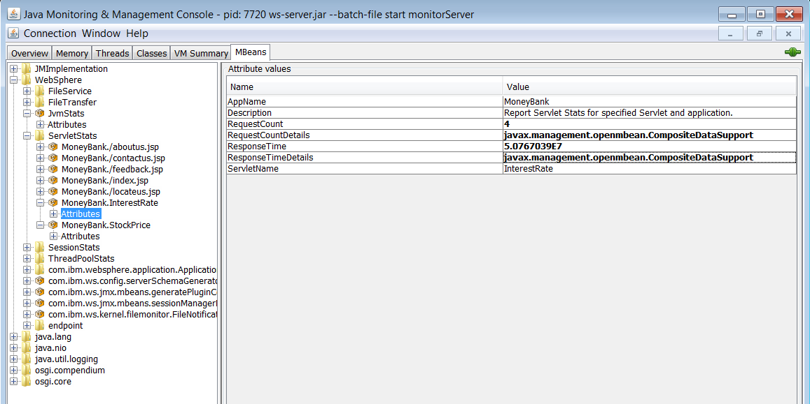

- Double click one of the complex types, such as javax.management openmbean.CompositeDataSupport that corresponds to response time detail to get more information. Note that it shows minimum, maximum, and mean values:
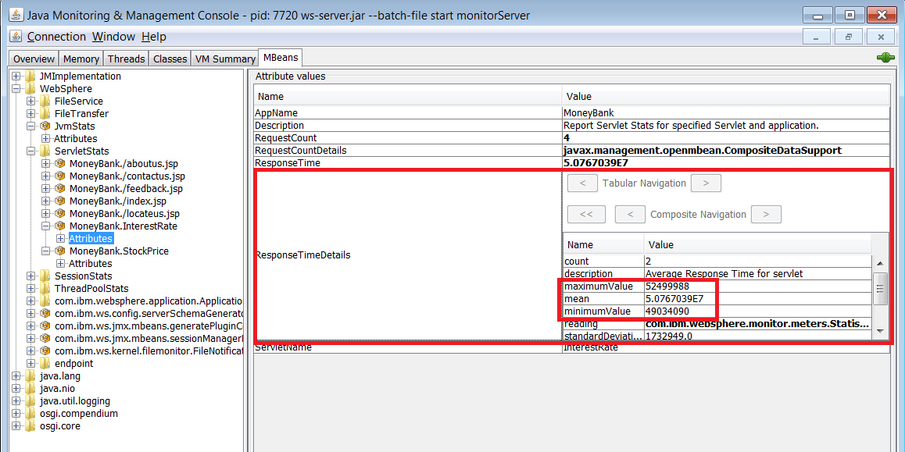
- Reload the page to: http://localhost:9080/MoneyBank/InterestRate , then refresh the JConsole screen by clicking the Refresh button at the bottom and check if the RequestCount went up by one.
- Explore the attributes of the other MBeans, such as ThreadPool.
- Close JConsole

IBM Monitoring and Diagnostics Tools for Java Health Center
The IBM Java Health Center contains a rich set of additional JVM monitoring function to help you monitor and diagnose your application server. Some of these additional benefits include:
  - Discovery of native memory and java heap leaks
  - Method profiling to discover which methods are taking the most time. Using sampling, it requires very little CPU overhead.
  - Identifying I/O bottlenecks
  - Threads: Lock contentions, Deadlock detection
  - Class histogram
For more information, visit: http://www.ibm.com/developerworks/java/jdk/tools/healthcenter
Normally Health Center is run from within the IBM Support Assistant, an Eclipse based environment offering. Many other support related tools are also available as part of IBM Support Assistant, such as :
  - Garbage Collection and Memory Visualizer for analyzing garbage collection behavior
  - Memory Analyzer for analyzing heap dumps
  - Thread and Monitor Dump Analyzer for monitoring thread dumps and
  - Log Analyzer for analyzing WebSphere logs.
Another option is to install it directly from the eclipse marketplace.
For this lab, we have included one version in the {LAB_HOME} directory.

Installing IBM Runtime Monitoring and Diagnostic Tools
- IBM Runtime Monitoring and Diagnostic Tools has already been installed in WDT. Note: There is no monitoring agent for the MAC JVM. There is one for the IBM JVM for Windows or Linux
  - If you want to install on your own Eclipse. Go to Help > Eclipse Marketplace..
  - Search for “health center”
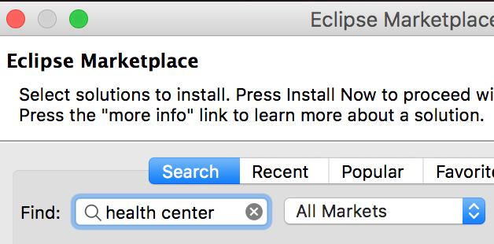

  - Click Install
  - Select Accept the terms of the license agreement and Click Finish
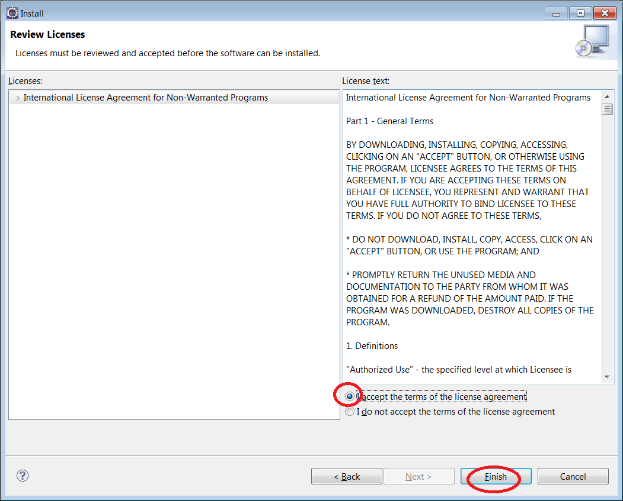

- If prompted to restart eclipse, click Yes

Configuring the Health Center Agent for Liberty Server
- From eclipse, navigate to Window Open Perspective Other
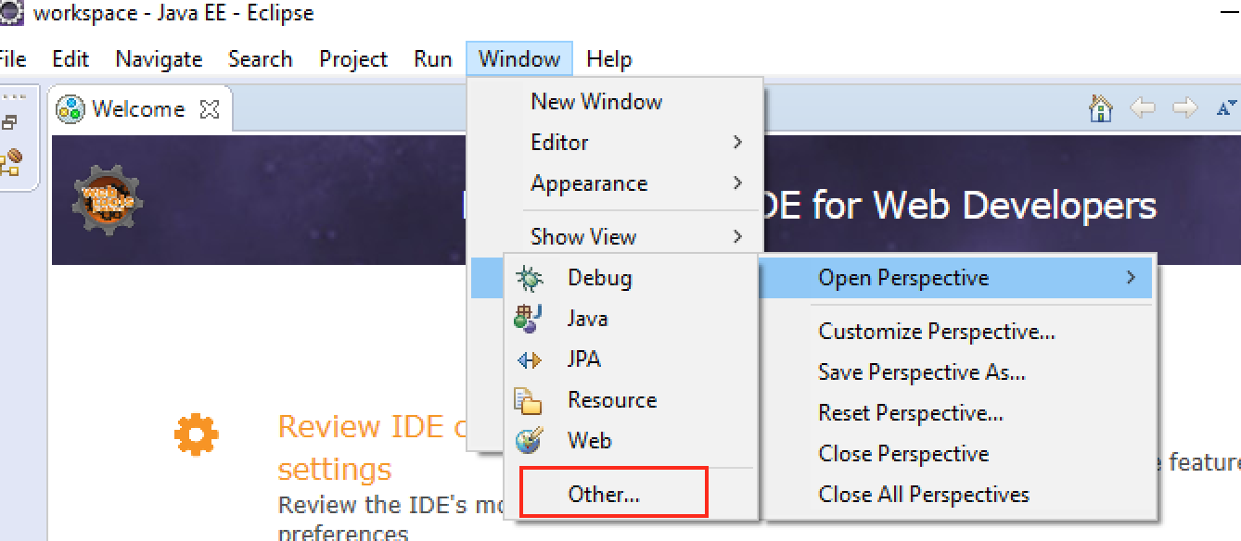
- Select Health Center Status Summary

- Navigate to File New Connection

- Verify that you already have the Health Center Agents installed by inspecting your JRE and ensuring that jre\lib\ext\healthcenter.jar exists. The Java SDKs included with this lab already have the agents installed. If you don’t see the agent, click Enabling an application for monitoring and follow the instructions to install the agent for your platform.
- Copy {LAB_HOME}\labs\management\5_Monitoring\jvm.options included with this lab to {LAB_HOME}\wlp\usr\servers\monitorServer directory.
- Inspect the file jvm.options and note the JVM options used to configure the agent. The configurations include :
  - Enablement of verbose garbage collection
  - Enablement of health center
  - Location of file to store health center data gather by the agent in the JVM
- Restart monitorServer
server stop monitorServer

server start monitorServer
- Check console.log and ensure that the health center messages and port number are printed as shown below :
INFO: Health Center agent started on port 1972

- Back in eclipse, click Next

- Enter localhost for Hostname, 1972 for Port
- Click on No Security radio button as security is not enabled on the Liberty Server.
- Note that you will want to enable security if accessing the server remotely, but it is out of scope of this lab.
- Click Finish

Using IBM Monitoring and Diagnostics Tools for Java Health Center
- Look at the Status pane, and note that what is unavailable:
  - CPU utilization: a current restriction
  - Method Trace: requires additional configuration, and outside the scope of this lab
  - WebSphere Real Time: requires real time option for the JRE
- Click Classes to see the list of classes loaded in the JVM.

- Enter InterestRate as filter, and click Apply.
Note :
If you don’t see the classes, first access the below web page.
http://localhost:9080/MoneyBank/InterestRate

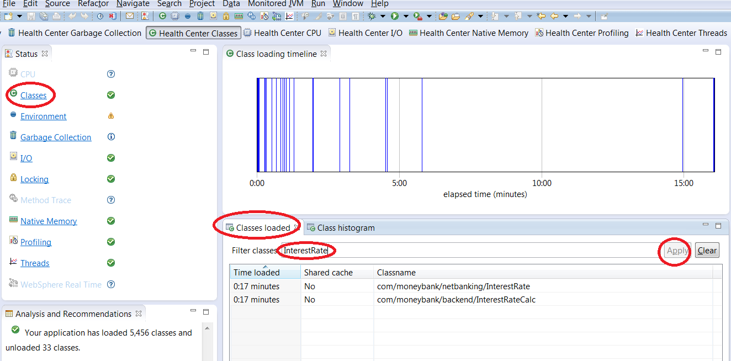

- Click Class Histogram, followed by Collect histogram data. Wait for the data to appear. This tells you the number of instances for each class, sorted by number of instances.
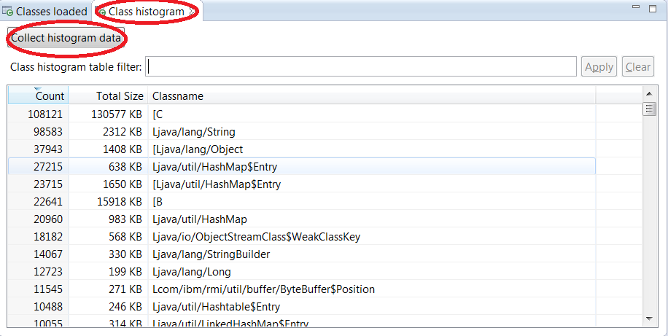
- Click Profiling then in the Method profile pane click Self to sort in descending order.
Profiling helps you gauge which methods are taking the most time. It employs statistical sampling to record which methods are running. Methods that are called often, or take a long time to complete, are shown. The Self column lists proportion of time each method has been sampled. The one with the largest percentage is sampled the most often, and therefore either called the most often, or spends the most time.
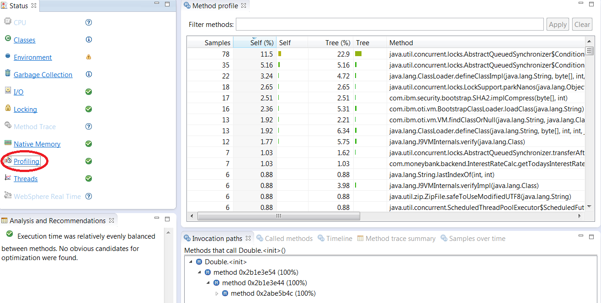

Note :
Profiling is not useful if the application is spending significant time doing I/O, or in garbage collection, or waiting for locks. Therefore, you should check those areas in the health center as well.

- Click on one of the methods. The invocation paths shows who is calling the method, and the percentage for each caller.
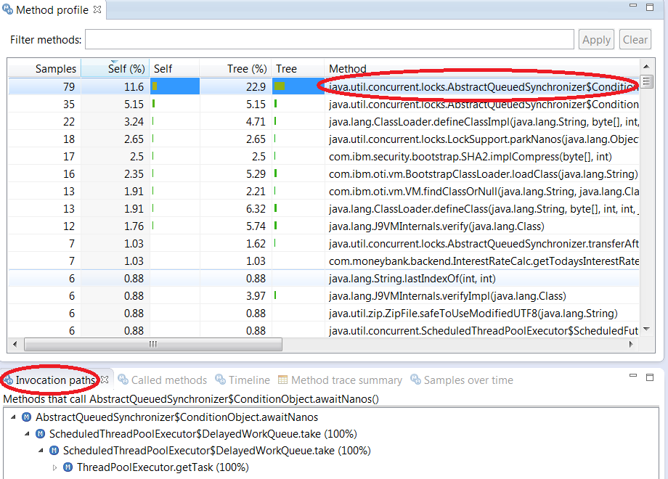
- Click Called methods to show the methods being called by the method you selected, and percentage of samples
- Click Timeline to see when the method is called.
- Click Samples over time to show the number of methods in the sample aggregated every two seconds.

- Back in the Method profile pane, click Tree (%) to sort in descending order. This gives the percentage of samples where the method is found on the call stack. This can also be a good indication of where the code is spending most of its time
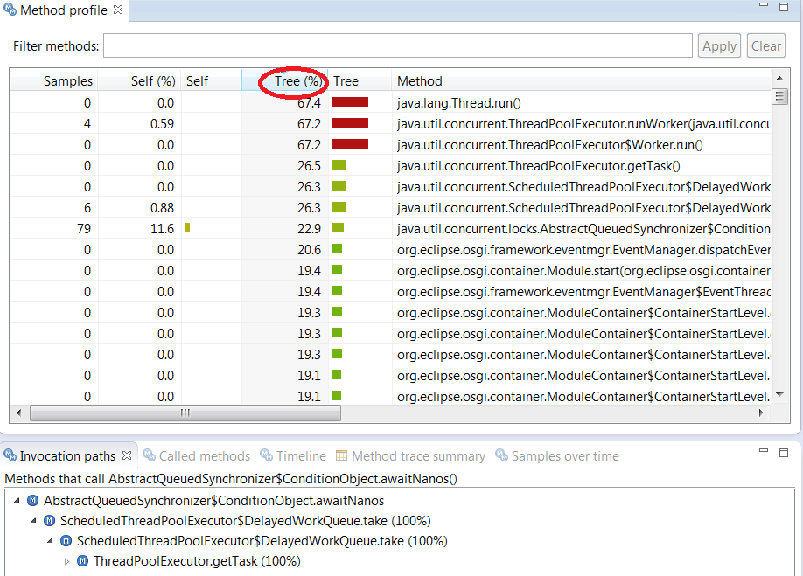

- Click Garbage Collection, and note the information being reported in various panes. Since the JVM is in equilibrium without load, there is not much of interest to see. Take note of the heap size, GC pause time and view the GC summary.
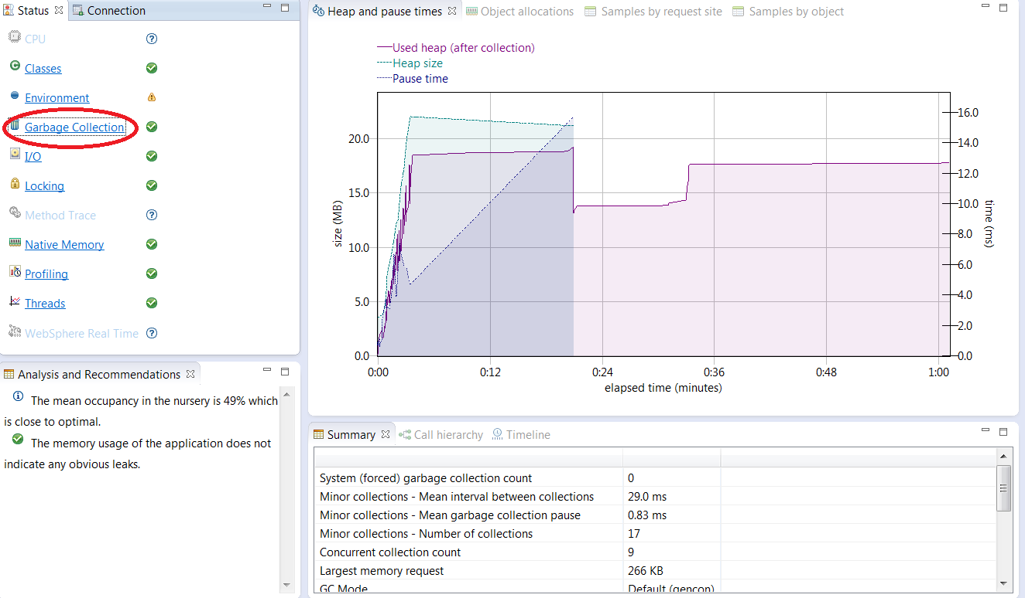
- Click on “Native Memory” to look at native memory usage.
- Click on I/O Files Open to view the number of open files over time.
- Click File I/O to view when files are opened or closed.

- Click Locking and view the Monitor pane. Hover the Mouse on each column name to get a better description.
For Example:
The column %miss is the percentage of “Gets” that result in a miss. A miss occurs when a thread tries to get a lock already owned by some other thread. A high number of misses is an indication of lock contention.
The Gets column shows the number of times a thread tries to get a monitor.
The Slow column shows the number of “gets” that result in a miss.
The Recursive column shows the number of times a thread gets a monitor that it already owns.
The % util is the percent utilization, meaning the amount of time the lock was held divided the total time spent monitoring the JVM.
Average hold time is the average time a thread spends while holding the monitor, measured in processor ticks.
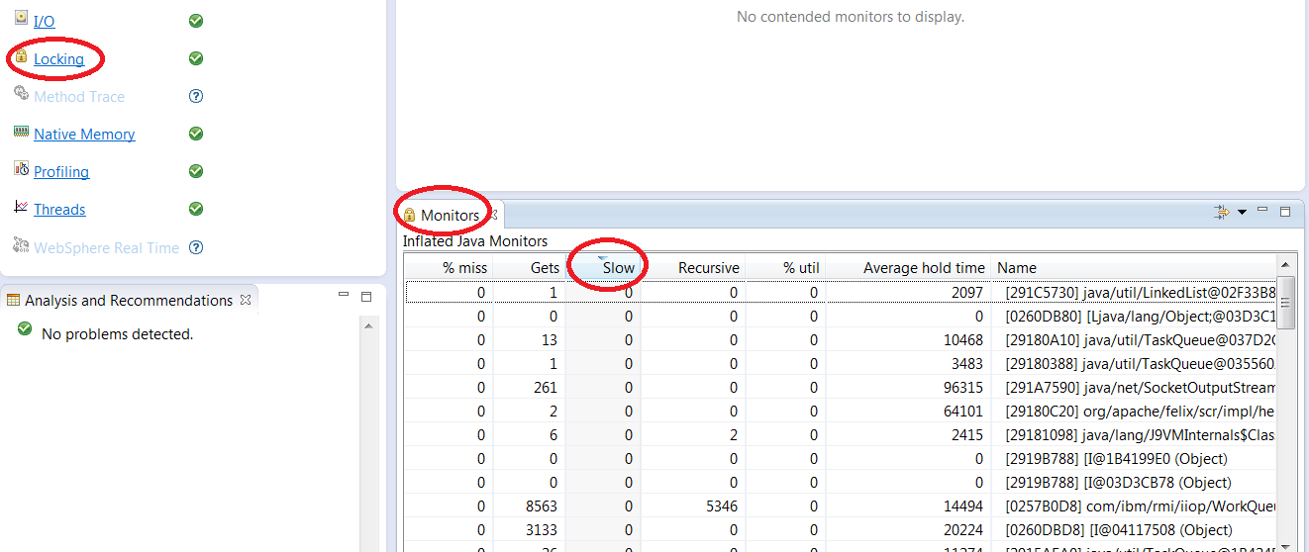
- Click Threads to see a list of threads, and their states. Click on each thread to see what monitor it owns, and what it’s waiting on.

Using IBM Monitoring and Diagnostics Tools for Java Health Center to Debug a Response Time Issue
In this section, we will place the application server under load using JMeter, while monitoring from the health center to resolve the high response time issue identified earlier through JConsole.
- Install JMeter by unzipping the contents of {LAB_HOME}\apache-jmeter-3.2.zip to {LAB_HOME}\apache-jmeter-3.2
- Set JAVA_HOME to {LAB_HOME}/wlp/java/jre or {LAB_HOME}\wlp\java\jre
- Run the command to start JMeter :
{LAB_HOME}\apache-jmeter-3.2\bin\jmeter
- Right click Test Plan and navigate to Add Threads (User) Thread
- Change number of threads (users) to 10 to simulate 10 users, and to loop forever
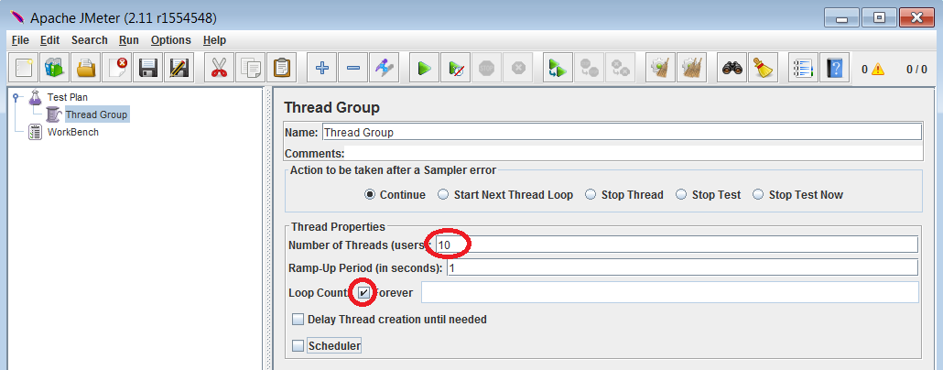
- Right click Thread Group, navigate to Add Sampler HTTP Request.
- Set the host to localhost, port to 9080, and the path to /MoneyBank/InterestRate.
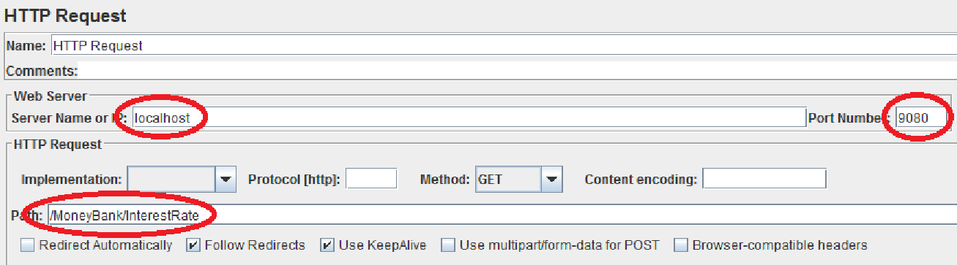
- Right click Thread Group and navigate to Add Listener Summary Report
- Restart monitorServer so we start from a new baseline
- Start Task Manager on Windows to monitor the CPU to verify whether the application is CPU bound. Use equivalent CPU monitoring tool, like top, for your operating system if not using Windows. Below is an example during a sample run :
- Back to JMeter, start the run by clicking on the Start button.

- Save the changes if prompted.
- Verify there are no errors.
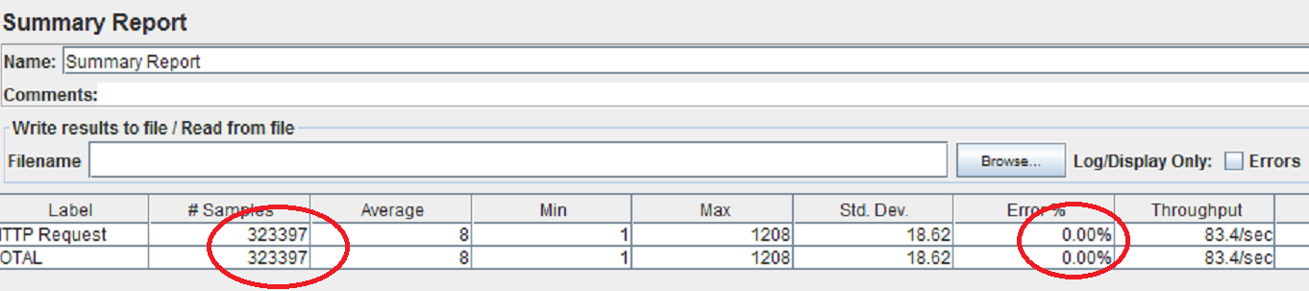
- Connect Health Center to the monitorServer
- Verify Garbage Collection behavior looks OK
- Click on Profiling. Note that most of the time is spent in the Double() constructor while processing servlet request on GetInterest servlet.
- Optional: Examine the MoneyBank application source code to find where the Double() constructor is called, and why it’s using so much CPU.
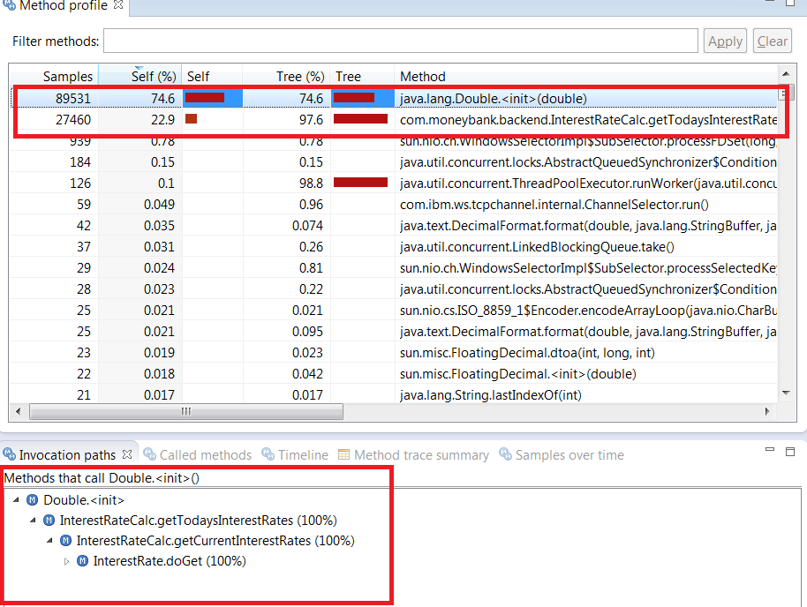
- Back to JMeter, click Stop button.
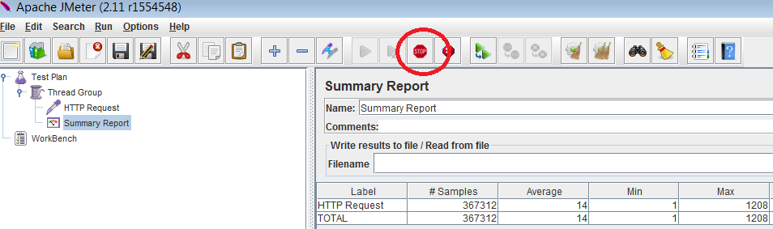
- Stop the Application Server monitorServer

Summary
In this lab you have learned:
- Enabling monitoring feature on .
- Use JConsole to monitor the Liberty Server
- Use IBM Monitoring and Diagnostics Tools for Java Health Center to monitor the Liberty Server
- Introduce load to the server and debug a response time issue.

- Notices
This information was developed for products and services offered in the U.S.A.
IBM may not offer the products, services, or features discussed in this document in other countries. Consult your local IBM representative for information on the products and services currently available in your area. Any reference to an IBM product, program, or service is not intended to state or imply that only that IBM product, program, or service may be used. Any functionally equivalent product, program, or service that does not infringe any IBM intellectual property right may be used instead. However, it is the user's responsibility to evaluate and verify the operation of any non-IBM product, program, or service.
IBM may have patents or pending patent applications covering subject matter described in this document. The furnishing of this document does not grant you any license to these patents. You can send license inquiries, in writing, to:
IBM Director of Licensing
IBM Corporation
North Castle Drive
Armonk, NY 10504-1785
U.S.A.
For license inquiries regarding double-byte (DBCS) information, contact the IBM Intellectual Property Department in your country or send inquiries, in writing, to:
IBM World Trade Asia Corporation
Licensing
2-31 Roppongi 3-chome, Minato-ku
Tokyo 106-0032, Japan
The following paragraph does not apply to the United Kingdom or any other country where such provisions are inconsistent with local law: INTERNATIONAL BUSINESS MACHINES CORPORATION PROVIDES THIS PUBLICATION "AS IS" WITHOUT WARRANTY OF ANY KIND, EITHER EXPRESS OR IMPLIED, INCLUDING, BUT NOT LIMITED TO, THE IMPLIED WARRANTIES OF NON-INFRINGEMENT, MERCHANTABILITY OR FITNESS FOR A PARTICULAR PURPOSE. Some states do not allow disclaimer of express or implied warranties in certain transactions, therefore, this statement may not apply to you.
This information could include technical inaccuracies or typographical errors. Changes are periodically made to the information herein; these changes will be incorporated in new editions of the publication. IBM may make improvements and/or changes in the product(s) and/or the program(s) described in this publication at any time without notice.
Any references in this information to non-IBM Web sites are provided for convenience only and do not in any manner serve as an endorsement of those Web sites. The materials at those Web sites are not part of the materials for this IBM product and use of those Web sites is at your own risk.
IBM may use or distribute any of the information you supply in any way it believes appropriate without incurring any obligation to you.
Any performance data contained herein was determined in a controlled environment. Therefore, the results obtained in other operating environments may vary significantly. Some measurements may have been made on development-level systems and there is no guarantee that these measurements will be the same on generally available systems. Furthermore, some measurements may have been estimated through extrapolation. Actual results may vary. Users of this document should verify the applicable data for their specific environment.
Information concerning non-IBM products was obtained from the suppliers of those products, their published announcements or other publicly available sources. IBM has not tested those products and cannot confirm the accuracy of performance, compatibility or any other claims related to non-IBM products. Questions on the capabilities of non-IBM products should be addressed to the suppliers of those products.
All statements regarding IBM's future direction and intent are subject to change or withdrawal without notice, and represent goals and objectives only.
This information contains examples of data and reports used in daily business operations. To illustrate them as completely as possible, the examples include the names of individuals, companies, brands, and products. All of these names are fictitious and any similarity to the names and addresses used by an actual business enterprise is entirely coincidental. All references to fictitious companies or individuals are used for illustration purposes only.
COPYRIGHT LICENSE:
This information contains sample application programs in source language, which illustrate programming techniques on various operating platforms. You may copy, modify, and distribute these sample programs in any form without payment to IBM, for the purposes of developing, using, marketing or distributing application programs conforming to the application programming interface for the operating platform for which the sample programs are written. These examples have not been thoroughly tested under all conditions. IBM, therefore, cannot guarantee or imply reliability, serviceability, or function of these programs.
- Trademarks and copyrights
The following terms are trademarks of International Business Machines Corporation in the United States, other countries, or both:
IBM | AIX | CICS | ClearCase | ClearQuest | Cloudscape
Cube Views | DB2 | developerWorks | DRDA | IMS | IMS/ESA
Informix | Lotus | Lotus Workflow | MQSeries | OmniFind
Rational | Redbooks | Red Brick | RequisitePro | System i
System z | Tivoli | WebSphere | Workplace | System p
Adobe, Acrobat, Portable Document Format (PDF), and PostScript are either registered trademarks or trademarks of Adobe Systems Incorporated in the United States, other countries, or both.
Cell Broadband Engine is a trademark of Sony Computer Entertainment, Inc. in the United States, other countries, or both and is used under license therefrom.
Java and all Java-based trademarks and logos are trademarks of Sun Microsystems, Inc. in the United States, other countries, or both. See Java Guidelines
Microsoft, Windows, Windows NT, and the Windows logo are registered trademarks of Microsoft Corporation in the United States, other countries, or both.
Intel, Intel logo, Intel Inside, Intel Inside logo, Intel Centrino, Intel Centrino logo, Celeron, Intel Xeon, Intel SpeedStep, Itanium, and Pentium are trademarks or registered trademarks of Intel Corporation or its subsidiaries in the United States and other countries.
UNIX is a registered trademark of The Open Group in the United States and other countries.
Linux is a registered trademark of Linus Torvalds in the United States, other countries, or both.
ITIL is a registered trademark and a registered community trademark of the Office of Government Commerce, and is registered in the U.S. Patent and Trademark Office.
IT Infrastructure Library is a registered trademark of the Central Computer and Telecommunications Agency which is now part of the Office of Government Commerce.
Other company, product and service names may be trademarks or service marks of others.



© Copyright IBM Corporation 2018.
The information contained in these materials is provided for informational purposes only, and is provided AS IS without warranty of any kind, express or implied. IBM shall not be responsible for any damages arising out of the use of, or otherwise related to, these materials. Nothing contained in these materials is intended to, nor shall have the effect of, creating any warranties or representations from IBM or its suppliers or licensors, or altering the terms and conditions of the applicable license agreement governing the use of IBM software. References in these materials to IBM products, programs, or services do not imply that they will be available in all countries in which IBM operates. This information is based on current IBM product plans and strategy, which are subject to change by IBM without notice. Product release dates and/or capabilities referenced in these materials may change at any time at IBM’s sole discretion based on market opportunities or other factors, and are not intended to be a commitment to future product or feature availability in any way.
IBM, the IBM logo and ibm.com are trademarks or registered trademarks of International Business Machines Corporation in the United States, other countries, or both. If these and other IBM trademarked terms are marked on their first occurrence in this information with a trademark symbol (® or ™), these symbols indicate U.S. registered or common law trademarks owned by IBM at the time this information was published. Such trademarks may also be registered or common law trademarks in other countries. A current list of IBM trademarks is available on the Web at “Copyright and trademark information” at ibm.com/legal/copytrade.shtml
Other company, product and service names may be trademarks or service marks of others.


